**Azure App Service**

Microsoft’s Platform as a Service (PaaS) offering is called App Service. We use it to host backend services for mobile applications, REST APIs, and web applications.

Which programming language or framework you have used doesn’t really matter. The azure app service can host web applications and services created with any of the following programming languages or frameworks. It might be:

* .NET
* .NET Core
* Java
* Ruby
* Node.js
* PHP
* Python

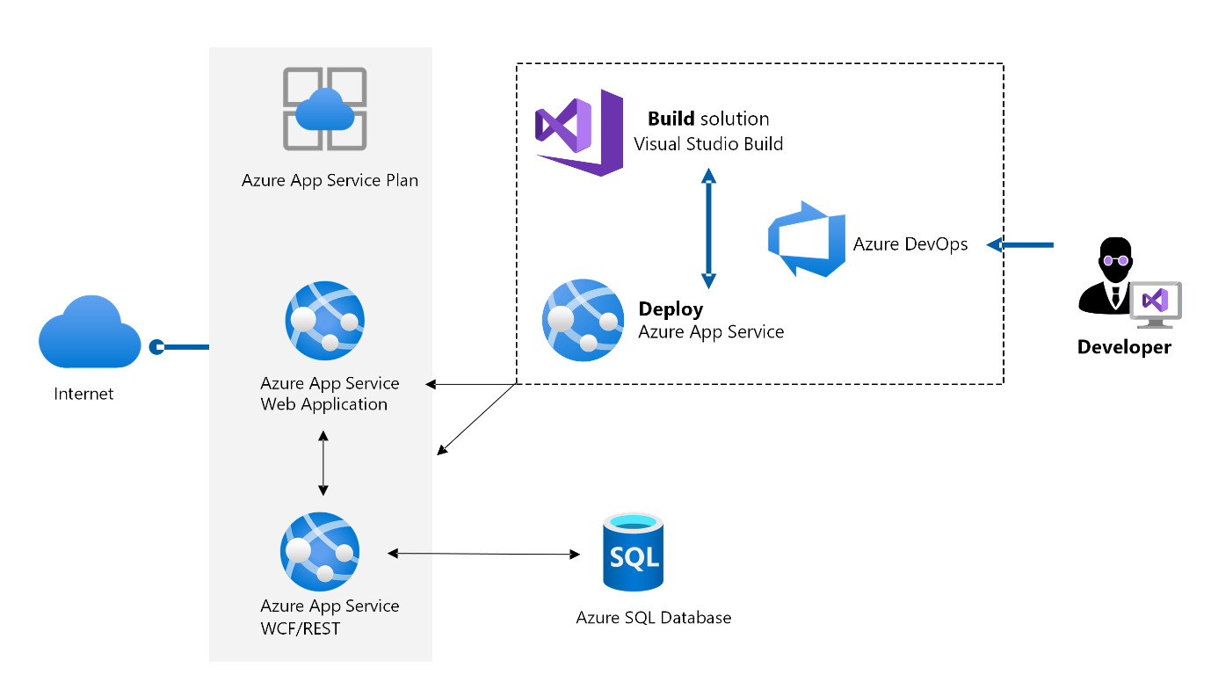

**Azure Kubernetes Service (AKS)**

The alternative option is to deploy an application in Azure using the increasingly well-liked Kubernetes platform.

With its Azure Kubernetes Service, Azure offers a fully managed Kubernetes solution. If you are familiar with Kubernetes, it works fairly well and you can get up and running quickly.

Currently, Kubernetes is an open-source industry standard for automatically deploying, scaling, and managing containerized applications.  
It is widely used and has all the features needed to create a website that is both highly scalable and resilient.

Let’s now compare the two options quickly while keeping important requirements in mind.

**High Availability**

A crucial requirement for resilient applications is high availability.

High availability is natively supported in a single region in AppService and AKS. At least three availability zones are present in a single region. A customised solution utilising Azure Traffic Manager can also be used to achieve multi-region availability if that is required.

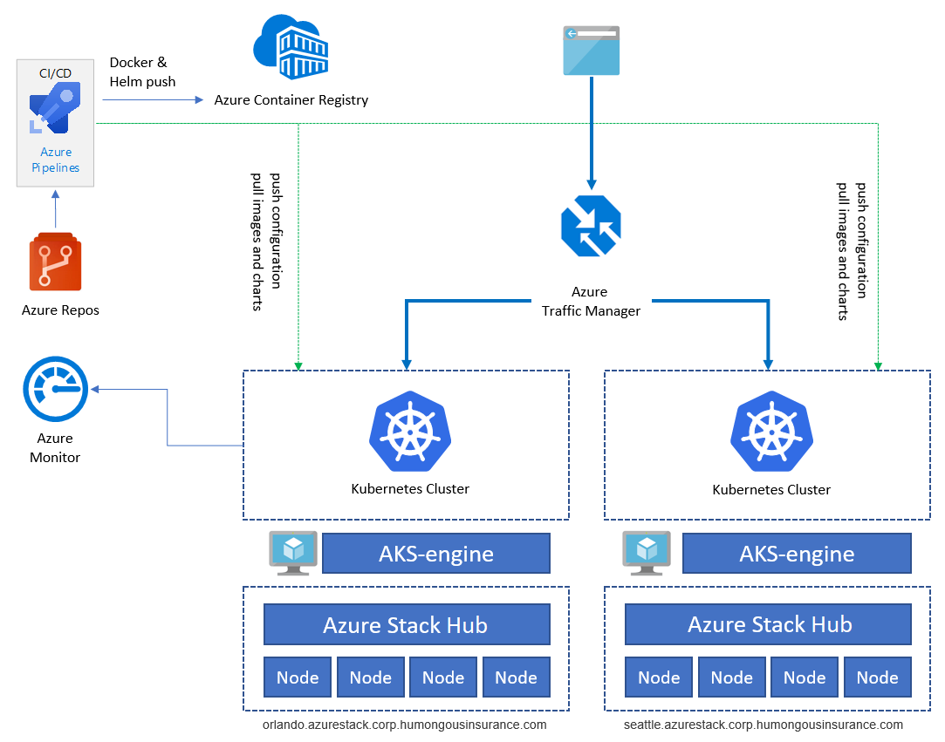

AppService supports only 5 languages whereas for docker we can do in all supporting formate.